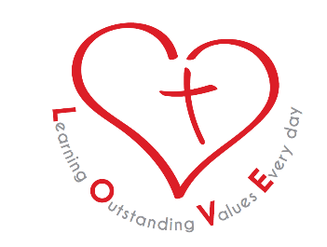

November 2018

Dear Applicant

Part Time Class TA Level 2 Maternity cover afternoons Monday – Friday to work in FS2

Applications are invited for the above post based at St Chad’s CofE Nursery and Infant School to work in FS2 (Reception). The successful applicant would be required to take up the position from January 2019.

Our Schools

St Chad’s is a small infants school with a big heart. Our school vision, LOVE, underpins every aspect of school life. We:

Look after our school and each other
Only ever do our best
Value everyone and remember our manners
Enjoy our learning!

We are very proud of our school’s long serving history and the strong links that we have with our community and St Augustine’s Church. Our children are nurtured by a friendly, enthusiastic and supportive school team who strive to give our children the very best. Every child in our care is know, valued and loved as an individual.

Although a Church of England school, we serve a rich, diverse and multicultural catchment. English is the second language for the majority of our children. We value the importance of play and communication: language, talk and vocabulary-teaching sits at the heart of our bespoke curriculum design.

There are currently 130 children on roll. We have a morning Nursery class two Reception Classes and three Key Stage 1 classes.

Life at St Chad’s is fun and filled with exciting and memorable learning. We value strong home-school partnerships and we endeavour to celebrate the achievements and Golden Moments of all of our children.

Applying for this post
The enclosed job description and person specification identifies the requirements of the position advertised. We are committed to safeguarding and promoting the welfare of our children and expect all staff and volunteers to share and be active with this commitment. As a Church of England school, the successful candidate will need to respect and support the Christian vision and ethos of the school.

This post is subject to an enhanced DBS check and satisfactory references.

Please complete your application, include details of any unspent convictions, cautions, reprimands, warning, binding overs and disciplinary action you may have been subject to.

The closing date for applications is Monday 7th January 2019 12 noon.
Shortlisted candidates will be invited to interview on Friday 11th January 2019 at 8:30 a.m. at St Chad’s Nursery and Infant School.

Applications should be returned to: Mr Richardson, School Business Administrator. christopher.richardson@stchads.derby.sch.uk

Unfortunately, it will not be possible to notify unsuccessful candidates of the result of their application.
We look forward to your application.

Ms. K Leach

Head of School

