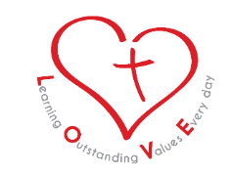

19th March, 2019
Ref: 0664
Updated School Vision and School Values

Dear Parents / Carers,

As you all know, we introduced a new school vision and ethos a couple of years ago in school (LOVE).

Over the past 12 months, we have been working hard to prepare for our Statutory Inspection of Anglican and Methodist Schools (SIAMS). The principal objective of SIAMS inspection is to evaluate the distinctiveness and effectiveness of all church schools. Recently, there have been changes to the framework that inspectors, with a greater emphasis on the school’s vision and values and how these permeate all aspects of school life.

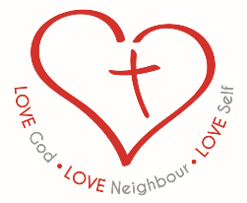
Although we are proud of our school’s history as a Church of England school, we are also proud of the diverse community in which we serve. We welcome all families from all faiths and backgrounds with open arms and an open heart. With all of the above in mind, we have made some changes to the wording that sits beneath our school logo so that it better reflects our Christian and inclusive, diverse and wonderful school and local community:

Love God; Love Neighbor; Love Self

Sitting alongside our vision will be our core values of love, friendship, compassion and respect.

Love: “Do everything with love”.
Friendship: “Encourage one another and build each other up”.
Compassion: “Be kind to one another”.
Respect: “Treat others as you want to be treated”.

We strive to be positive role models to our children, guiding and teaching them through our school’s ‘LOVE Promise’. We:

Look after our school and each other.
Only ever do our best.
Value everyone and remember our manners
Enjoy our learning!

I would like to say a special thank you to governors, staff, parents and children who have helped to inspire these changes to our school vision and values. You will begin to notice the updated wording on our letters and school website. Please note that there will be no changes to our school uniform.

Thank you, as always, for your continued support.

Yours faithfully,
K.Leach Reverend Andy Ward
Head of School Chair of Governors

Learning Outstanding Values Every Day
ST. CHAD’S C.E. (Cont.) NURSERY & INFANT SCHOOL

