Please choose and complete one activity each week. You can complete the activities in any order.
Remember to record your work in your Home Learning book and hand into your teacher Wednesday. If possible, ask somebody to take a photograph of you doing some of your Home Learning activities.
Write down numbers 0 to 100. Are all of your digits the correct way? Can you find any numbers in the environment? | Draw a picture of Rapunzel.  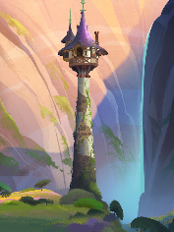  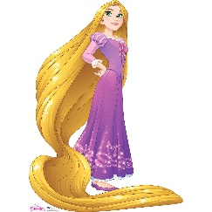  If you were Rapunzel, how would you feel once you escaped from the tall, dark tower? | 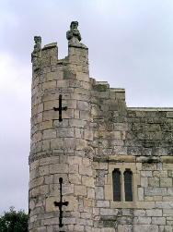  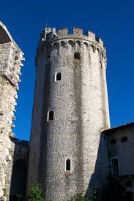  Design and make a castle. Can you make a castle that has towers and turrets? Bring your castle into school.
Collect and decorate a shoebox to help with our Christmas Shoebox Appeal.  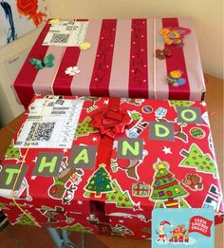 | Write a letter to somebody (maybe Santa!) and post it.  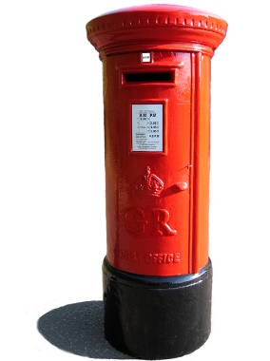  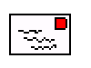 | Design and make a Remembrance poppy or wreath and bring it into school.  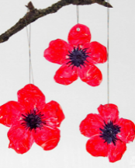  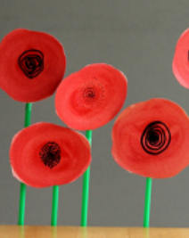  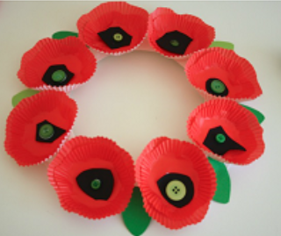
REMEMBER: read your school book 3 times a week and ask a grown-up to sign your reading record.

