10 Tips to help you and your child make going to school easier:
1 | 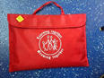 | Help get your child’s book bag ready the night before.
2 |  | Make sure your child’s uniform is ready the night before.
3 |  | Get them to bed on time so they have a good night’s sleep.
4 |  | Set the alarm clock early enough to allow plenty of time to get ready.
5 |  | Make sure your child has a healthy breakfast.
6 | 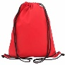 | Check that your child has everything before you leave the house: coat, book bag, PE kit…
7 |  | Leave plenty of time to get to school: punctuality is important.
8 |  | If your child is finding their school work too hard speak to their teacher.
9 |  | Talk to your child about what they did in school today.
10 |  | If you or your child are worried or unhappy about something, contact the school.

