English  Write a sentence about the beginning, middle and end of the story  Recite ‘We’re going on a lion hunt’ story map | 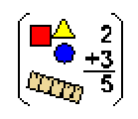  Maths  - Write numbers 1-100  - Count backwards from 100  - Go on a shape hunt around the house and find a cube, cuboid, cone and sphere  - Recall 10, 5 and 2 times tables | 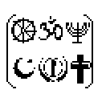  Religious Education (RE)  Decorate an Easter egg with a pattern.
Let’s Talk!

Why do Christians celebrate Easter?
Geography  Can you write 5 facts about Africa.  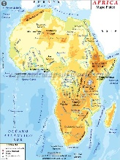 | Science  Draw and label African animals (Lion, elephant, giraffe and zebra.)  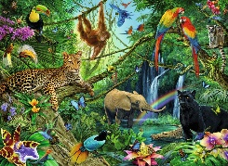 | Art  Find different animal print materials and describe them to an adult.
Let’s Talk!  What’s the weather like in Africa? | Let’s Talk!  What noises do these animals make? | Let’s Talk!  What does camouflage mean?
REMEMBER! Every week you should be:
- Reading to an adult 3 times a week and asking them to sign your Reading Record
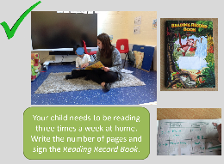
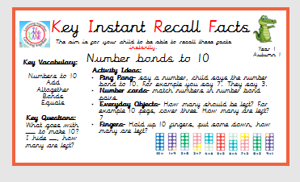
- Practising your KIRFs

